Educating the Construction Industry Today…and Tomorrow

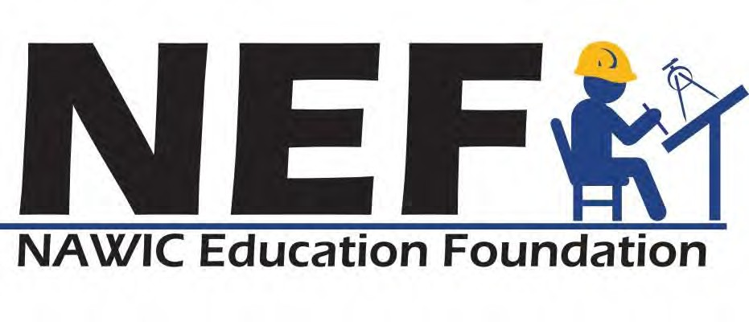
Block Kids Program

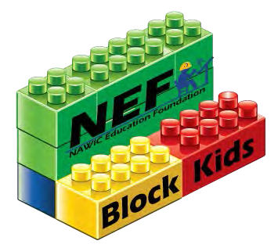

Sponsor Guidelines

Note to Sponsors & Participants:

Block Kids is a program administered by the NAWIC Education Foundation, a 501(c)(3) Charitable Corporation. NEF shall be the sole authority on rules and guidelines regulating same and for decisions relating to the continued use of this program. At the sole discretion of the NEF Board of Trustees, this program may be discontinued at the conclusion of any year's annual program, with notification given to NAWIC, to all NAWIC Chapters and to Sponsors that the program will not be continued the following year.

ABOUT

The Construction Industry faces a workforce shortage that poses a serious problem for our national economy. In order to meet the demand for construction, the industry needs to attract, educate and train about 240,000 newcomers annually.

The Block Kids Program introduces children to the construction industry in an effort to create an awareness of and to promote an interest in future careers in one of the many facets of the industry. Sponsors include NAWIC Chapters and other organizations.

The Block Kids Building Program is a national building competition which is sponsored by NAWIC Chapters and other organizations that wish to promote children in grades K-12 about construction careers.

The program is non-discriminatory and as such is open to all elementary school children in grades Kindergarten (K) through sixth (6). All eligible children must participate through a recognized Sponsor.

IMPORTANT DATES

ALL ENTRIES TO REGION CHAIR NO LATER THAN FEBRUARY 15th

ALL ENTRIES TO NATIONAL NO LATER THAN MARCH 15th

NATIONAL ANNOUNCES WINNERS at NAWIC Annual Conference

NAWIC EDUCATION FOUNDATION BLOCK KIDS BUILDING PROGRAM

COMPETITION RULES

PROGRAM SPONSORS

- Sponsor

  - Any NAWIC Chapter, group, organization, association, or school may be the sponsor for the competition in their respective area. All contests shall conform to the rules and parameters as set forth by the NAWIC Education Foundation. Only winners from NAWIC Chapters will be eligible to enter the NAWIC Region competitions. Non-NAWIC Sponsors will enter the national competition only.

  - Sponsors shall designate the date, time and place for the competition to be
held.

  - The program shall be open for participation to all children enrolled in grades Kindergarten (K) through six (6), except for previous National Winners or National Honorable Mention Recipients of the NEF Block Kids Building Program.

  - All construction shall be completed using approved materials only.

    - All "blocks" shall be interlocking types of the “Micro” size - 2, 4, 6, 8, and 10 posts. (No “Duplo” size blocks).

    - Each participant shall have a minimum of 75 and a maximum of 100 blocks with which to complete their project. Use of specialty pieces (windows, doors, wheels, people, animals, etc.) cannot be used and will disqualify any Regional and/or National entries.

    - Each participant may also use up to three (3) additional items, supplied by the Sponsor, from the following list:

      - Small rock/stone - not more than two (2) inches in diameter
      - String - not longer than twelve (12) inches in length
      - Foil - not larger than 18 inches x 18 inches*
      - Construction Paper – not larger than 18 inches x 18 inches*

*Each of these items may be broken or torn into smaller pieces, provided the child does so without outside assistance. The use of scissors or knives are prohibited.

    - Each participant may use a combination of three items

    - Each participant shall be provided with a work area of approximately two
(2) feet x two (2) feet on which to build their project

    - Each participant shall have a minimum of forty (40) minutes and a maximum of one (1) hour to complete their project. Time starts when all children are ready to begin.

    - Each child shall use the blocks supplied to them. Children cannot exchange blocks with each other or with an “exchange table”.

    - Each child shall be permitted to build the project of their choice, provided that it in some way relates to the construction industry. Construction equipment is acceptable. Sponsors shall use their discretion in determining the acceptability of projects, as relates to their respective area. ***Projects which depict people or animals will not be allowed.

JUDGING

- Judging of each project shall be the responsibility of the Sponsor. Judges may be NAWIC members, other association members, local businesses, media people, etc. provided that no individual is permitted to judge a participant who is a relative or friend.

  - Judges shall also act as monitors during the building contest. It shall be the responsibility of the judges/monitors to ensure that each child completes the project entirely on their own. It is suggested that parents/guardians be provided with an area away from the children where they may wait until the conclusion of the contest.

  - All judging shall be conducted using the official scoring forms, oral interview questions and other criteria as established by these Guidelines. (Forms BK #2 & BK
#3) No other information will be considered in the selection of Chapter, Region Semi-finalists and National Winners.
  - Sponsors may have as many winning categories as they like. Only one (1) entry per NAWIC Chapter may be sent to the NAWIC Region Block Kids Committee Chair for further consideration. Non-NAWIC Sponsors will submit only one (1) entry per competition to NEF National Office for further consideration.

    - It shall be the sole responsibility of the Sponsor to provide for prize awards, mementos, and/or goody bags, etc., for contest winners and participants. The Certificate of Participation template is available on the NEF website. Logos are available, upon request.

    - Sponsors are encouraged to provide for at least a first-place prize and a token memento for each participant.

NAWIC CHAPTER COMPETITION SUBMISSION TO NAWIC REGION CHAIR

All NAWIC Chapter’s winning entries must be submitted to the NAWIC Region Block Kids Chair for region judging and must be received on the approved Chapter Submission Template no later than February 15th. No exceptions will be made.

- Each entry must include all of the following:

  - Block Kids Official Registration/Entry Form signed by entrant’s parent or guardian (BK#1)

  - Block Kids Official Oral Interview Question Form (BK#2)

  - Block Kids Official Sponsor Judging Form (BK#3)

  - Five (5) color photographs of the project taken from front view, back view, both side views and overhead. (This is important so that all entries may be judged equitably.) Note: Do not submit photos of participants.

Block Kids Official Sponsor Submittal Form (BK#4)

  - Block Kids Stats Form (BK#9)

Label pictures with basic descriptions (i.e., foil represents water, etc.)

- Video tapes will not be considered for Region or National judging

- No materials or information other than that requested in Item 1 (above) will be considered for judging purposes

Sponsor questions should be directed to their Region Block Kids Chair. Chain should be as follows: Chapter Block Kids Chair to Region Block Kids Chair to NEF National Block Kids Chair to NEF National Office.

Publicity for each program shall be the responsibility of the Sponsor. The Block Kids Logo, as shown on the illustrations included with these guidelines, shall be the official logo of the NEF Block Kids Building Program and no other program logo may be used.

Additional contact information:
NAWIC Education Foundation
(817) 764-2638 ext 6
Email: nawicedu@gmail.com

NAWIC REGION COMPETITION SUBMISSION

Region judging shall be conducted by the NAWIC Region Block Kids Committee Chair who may, at their discretion, invite others to participate in the selection of one (1) Region winner to be submitted for the NEF National Block Kids Competition.

NAWIC Region Block Kids Committee Chair shall not accept more than one entry from each Chapter in their respective Regions.

All local Chapter entries must be received on the approved Chapter Submission Template by the NAWIC Region Block Kids Committee Chair no later than February 15th.. Entries received after that date will be considered ineligible and shall not be considered in the selection of the Region semi-finalist.

All entries submitted to NAWIC Region Block Kids Committee Chair by the Chapter Block Kids Chairs must include all of the following:

- Block Kids Official Registration/Entry Form signed by entrant’s parent or guardian (BK#1)

- Block Kids Official Oral Interview Question Form (BK#2)

- Block Kids Official Sponsor Judging Form (BK#3)

- Five (5) color photographs of the project taken from front view, back view, both side views and overhead. (This is important so that all entries may be judged equitably.) Note: Do not submit photos of participants.

Block Kids Official Sponsor Submittal Form (BK#4)

- Block Kids Stats Form (BK#9)

Judging shall be done using the authorized contest forms only. No additional information or material shall be considered in the selection of the NAWIC Region semi-finalist winner.

Due to the distribution of blocks, not all contestants are able to work with the same exact blocks, and none are allowed “specialty pieces” such as doors, windows, wheels, people, animals, etc. The overall project should be reviewed, and the following criteria considered:

- Were at least 75 blocks used?

- Did the builder use only prescribed building materials? Did they only use 3 out of the 4 additional listed materials?

- Were specialty pieces used? (Note: Specialty Pieces disqualify Entrant and Projects which depict people or animals will not be allowed)

- The project should win because of overall design, concept, construction and the interview.

The official Block Kids Logo as detailed in these guidelines and shown on the illustrations included with these guidelines, shall be authorized only for use in connection with this contest and Region Judging.

Region Block Kids Chair questions should be directed to NEF National Block Kids Chair. Chain should be as follows: Chapter Block Kids Chair to Region Block Kids Chair to NEF National Block Kids Chair to NEF National Office.
NAWIC REGION & Non-NAWIC SPONSOR COMPETITION SUBMISSION

All NAWIC Region semi-finalist entries and non-NAWIC Sponsor finalist entries are submitted for consideration in the NEF National Block Kids Competition must be received on the approved Chapter Submission Template no later than March 15th of each year by NEF National Block Kids Chair.
Each entry must include all of the following:

- Block Kids Official Registration/Entry Form (BK #1) received from Chapter or non-NAWIC sponsor

- Block Kids Official Oral Interview Question Form (BK #2) received from Chapter or non- NAWIC sponsor

- Block Kids Official Sponsor Judging Form (BK #3) received from Chapter or non-NAWIC sponsor

- Block Kids Official Sponsor Submittal Form. (BK#4) received from Chapter or non- NAWIC sponsor

- Block Kids Official Region Judging Form (BK #5) Not needed for non-NAWIC sponsors

- Block Kids Image Announcement Form (BK #6)

- Block Kids Region Submittal Form (BK #7) Not needed for non-NAWIC sponsors

- Block Kids Stats Form (BK #9) received from Chapter or non-NAWIC sponsor

- Five (5) color photographs of the project taken from front view, back view, both side views and overhead. (This is important so that all entries may be judged equitably.) Note: Do not submit photos of participants.

- Block Kids Stats Form (BK #10) This form will be compiled by the Region Chair using information from each chapter’s Stats Form along with a copy of each Chapters Stats Form. Non-NAWIC Sponsors will submit the form with entry.

NATIONAL JUDGING

- National Judging shall be conducted by selected individuals, as coordinated by the NEF National Block Kids Chair.

  - Only those complete entries received on the approved Chapter Submission Template by the deadline of March 15th will be considered for National Awards.
  - National judging may result in the selection of the following: One (1) First Place Winner
One (1) Second Place Winner One (1) Third Place Winner

  - National Prizes may include the following or something of similar value:

*First Place: Apple IPad
*Second Place: Apple IPad Mini
*Third Place: Kindle Fire

*(NEF reserves the right to make comparative value substitution of prizes.)

- The National Winners shall be announced at NAWIC Annual Conference.

  - Chapters can choose to have the national prize delivered to the Chapter Chair for distribution to the winner or may decide to have the prize sent directly to the student.

  - NAWIC Education Foundation Executive Office shall arrange for the purchase and distribution of the prizes to the Chapters/winners.

- Publicity at the Region and National levels shall be coordinated between the NAWIC Education Foundation Executive Office.

.

BK FORM #1

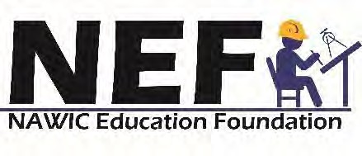
BLOCK KIDS BUILDING PROGRAM

Official Registration/Entry Form
Please fill out all information requested. Please print legibly.

STUDENT’S NAME:

MAILING ADDRESS:

CITY, STATE, PROVINCE, ZIP:

PARENT/GUARDIAN NAME:

HOME PHONE NUMBER: ______________________________ MALE _______ FEMALE _______

SCHOOL: GRADE:

SCHOOL STREET ADDRESS:

TEACHER:

CITY, STATE, PROVINCE, ZIP:

RELEASE SPONSOR
I hereby consent to my child participating in the
Block Kids Program and in the use of my child’s
name, entry, and interview in promoting or publishing this program or the NAWIC Education Foundation, now or at a future date. Further, I understand that this entry shall become the sole property of the NAWIC Education Foundation.

(Signature of Parent/Guardian)

(Sponsor/Region)

(Mailing Address)

(City/State/Zip)

RELEASE
I hereby consent to the use of my child's photograph in promoting or publishing this program or the NAWIC Education Foundation, now or at a future date.

(Signature Chair)

Must be received by:
_________________________________________

(Signature of Parent/Guardian)

(This form must accompany entry at all levels of judging.)

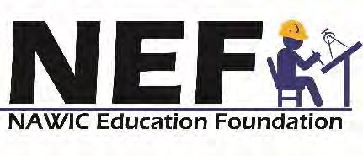

ELIGIBILITY REQUIREMENTS/CONTEST RULES

ELIGIBILITY
This contest is open to ALL children, currently enrolled in grades Kindergarten (K) through six (6), except PREVIOUS NATIONAL WINNERS. Entry in contest must be through a RECOGNIZED SPONSOR.

RULES
- All building projects must be completed where and when designated by Sponsor.
- All building projects must be completed within the allotted time.
- All building projects must be completed using approved materials only.
- All building projects must be relevant to the construction industry. Projects which depict people or animals will not be allowed.
- All building projects must be completed by entrant, with no outside assistance from parents, teachers, etc.
- Every participant must submit the Official Registration/Entry Form, signed by a parent or Guardian.

PRIZES
- Each of these eight Region semi-finalists winning Region entries will be submitted for consideration in the National finals, along with entries from non-NAWIC Sponsors, to become eligible for National prizes.
- There may be a First Place, Second Place and Third Place National prize award.
- Other prizes may be awarded at the discretion of local Sponsors.

PRIZE AWARD
- Region semi-finalists may be announced at NAWIC Region Forum.
- National winners will be announced at the NAWIC Annual Conference.

BK FORM #2
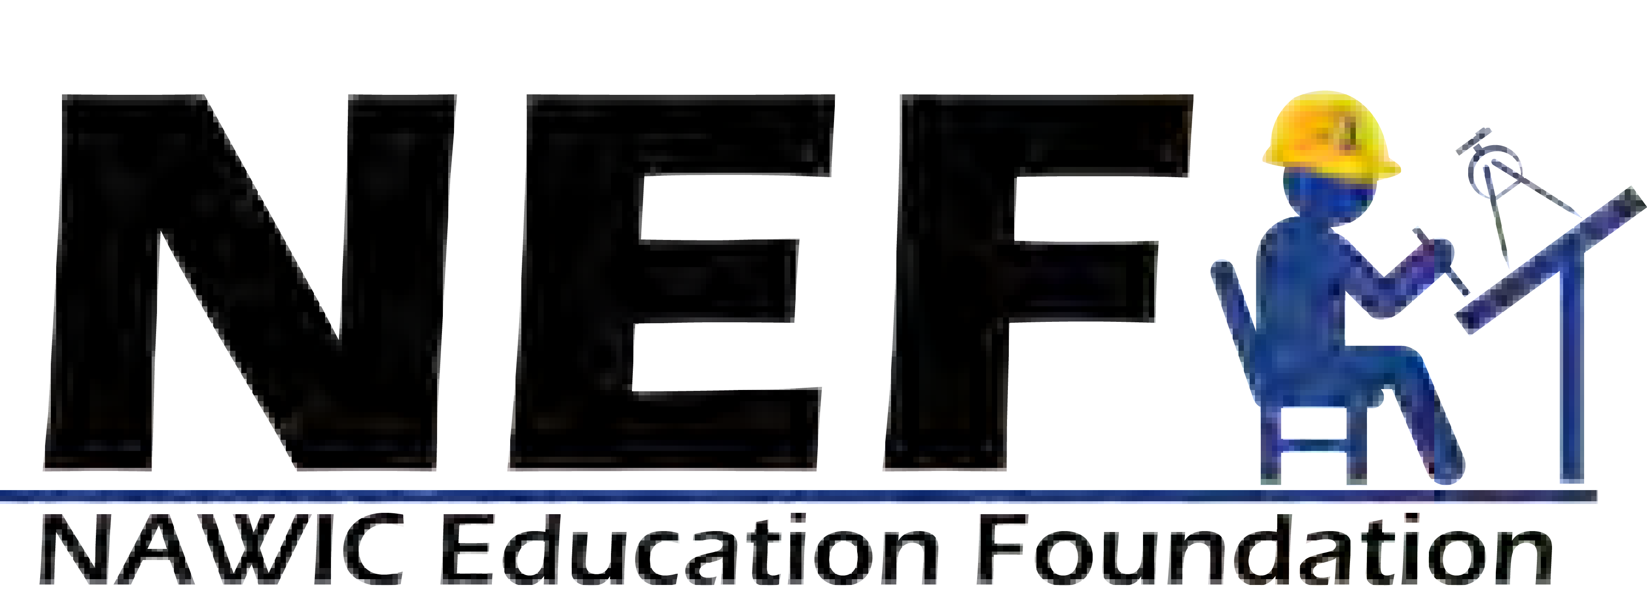
BLOCK KIDS BUILDING PROGRAM OFFICIAL ORAL INTERVIEW QUESTIONS
(For use by Local Sponsor)

Contestant Name: Grade: School:

NAWIC Chapter Name/Number or Sponsor:

- Tell us about your project and why you decided to build this:

- Who will use this? (What will people be doing when they use it?):

- If you did this again would you build it the same way, or are there parts you would want to change?

- Do you know about different types of construction work? What kind do you think you would like best?

- What would you like to be when you grow up?

- Did you have fun? Why or why not?

Description of the Project and Interviewer's Comments:

BK FORM #3

BLOCK KIDS BUILDING PROGRAM JUDGING FORM
(For use by Local Sponsor)

Contestant Name: Grade: School:

NAWIC Chapter Name/Number or Sponsor:

CATEGORIES SCORE

- ORIGINALITY/CREATIVITY OF PROJECT
(Score 1 - 25 points)

- ATTENTION TO DETAIL
(Score 1 - 10 points)

- USE OF PROVIDED MATERIAL(S)
(Score 1 - 10 points)

- ORAL PRESENTATION
(Score 1 - 25 points)

- ENTHUSIASM

(Score 1 - 10 points)

- REASON FOR PARTICIPATION
(Score 1 - 10 points)

- BONUS POINTS
(State reason) (Score 1 - 10 points)

TOTAL POSSIBLE SCORE: 100 POINTS

TOTAL SCORE

COMMENTS OF JUDGE(S):

(Signature of Judge) (Signature of Judge)

(Signature of Judge) (Signature of Judge)

Page 14

BK FORM #4

BLOCK KIDS BUILDING PROGRAM CHAPTER SUBMITTAL FORM

NAWIC CHAPTER NAME:

CHAPTER NUMBER: REGION:

PHONE/FAX/E-MAIL:

MAILING ADDRESS:

BLOCK KIDS CHAIRMAN:

DATE CONTEST WAS HELD: NUMBER PARTICIPATING:

OUR WINNING ENTRY WAS BUILT BY (NAME):

MAILING ADDRESS:

PARENT OR GUARDIAN NAME:

Complete this form and forward to your NAWIC Region Block Kids Chair with all of the following:

  - Block Kids Official Registration/Entry Form (BK Form #1)

  - Block Kids Official Oral Interview Question Form (BK Form #2)

  - Block Kids Official Judging Form (BK Form #3)

  - Block Kids Stats Form (BK Form #9)

  - Five (5) pictures are required of the winning project

Front view
Back view Top view
Each side view

BK FORM #5

NAWIC EDUCATION FOUNDATION BLOCK KIDS BUILDING PROGRAM JUDGING FORM
(For Region and Local Use)

CONTESTANT NAME: GRADE: NAWIC CHAPTER NAME/NUMBER: REGION:

CATEGORIES SCORE

- ORIGINALITY/CREATIVITY OF PROJECT
(Score 1 - 25 points)

- ATTENTION TO DETAIL
(Score 1 - 25 points)

- USE OF PROVIDED MATERIAL(S)
(Score 1 - 25 points)

- ORAL PRESENTATION
(Score 1 - 25 points)

TOTAL POSSIBLE SCORE: 100 POINTS

COMMENTS OF JUDGE(S):

REGION:
Region Chair Signature

DATE:
Region Chair Name
Distribution for Winning Entry Only

Send ONE (1) copy with attachments to: NEF Region Block Kids Chair

(This form must accompany entry at all levels of judging.)

BK FORM #6

BLOCK KIDS BUILDING PROGRAM IMAGE ANNOUNCEMENT FORM NAWIC REGION SEMI-FINALIST

Region Chair: Region:

Our winning entry was submitted by:

Name:

Mailing Address:

Parent/Guardian Name:

School Name: Grade:

The NAWIC chapter is:

Name/Number:

Mailing Address:

Block Kids Chairman:

Contest Date:

Date:
Region Chair’s Signature
Email:

Complete this form and forward to:

NEF Region Block Kids Chair - with all required attachments retain one copy for your files.

BK FORM #7

ALL ENTRIES MUST BE RECEIVED BY NEF NATIONAL BLOCK KIDS CHAIR

NO LATER THAN MARCH 15th
BLOCK KIDS BUILDING PROGRAM REGION SUBMITTAL FORM
Region Chair: _______________________________Region:

Email: Phone Number:

Chapter Name/Number:

Total Points Awarded by Chapter:

Total Points Awarded by Region Chair:

Winning Entry Built by:

School Name: Grade:

Number of Chapters participating in Region:

Number of Participants in Region:

Comments:

Complete this form and forward to:

NEF National Block Kids Chair

ALL ENTRIES MUST BE RECEIVED BY THE NEF NATIONAL BLOCK KIDS CHAIR
NO LATER THAN March 15th

BK FORM #8

NAWIC EDUCATION FOUNDATION BLOCK KIDS BUILDING PROGRAM
JUDGING FORM
(For National Use)

CONTESTANT NAME: GRADE: NAWIC CHAPTER NAME/NUMBER: REGION: CATEGORIES SCORE
- ORIGINALITY/CREATIVITY OF PROJECT
(Score 1 - 25 points)

- ATTENTION TO DETAIL
(Score 1 - 25 points)

- USE OF PROVIDED MATERIAL(S)
(Score 1 - 25 points)

- ORAL PRESENTATION
(Score 1 - 25 points)
Based on answers provided on oral interview question sheet

TOTAL POSSIBLE SCORE: 100 POINTS
TOTAL SCORE

COMMENTS OF JUDGE(S):

(Signature of Judge) (Signature of Judge)

(Signature of Judge) (Signature of Judge)

BK FORM #9
STATISTICAL DATA
(REQUIRED FOR CHAPTER AND NON-NAWIC SPONSORS)

The NAWIC Education Foundation uses the following data in obtaining grants and other financial contributions to maintain and create our quality educational programs. At no time are these results used to discriminate or exclude people based on race, gender, religion or creed.

How many Block Kids Programs did your Chapter sponsor this year?

How many girls participated in each program? (If more than one program, list separately)

How many boys participated in each program? (If more than one program, list separately)

Where was the program held?

What was the cost per child to put on the program?

If the Chapter received donations for the program, what was the approximate value of the donations?

Sponsor/Chapter Name & No.: Region:

Block Kids Chair: Daytime Phone:

Email Address:

Chapter Sponsors: Send this form with your Chapter entry to your NAWIC Region Block Kids
Chair.

NAWIC REGION BLOCK KIDS CHAIRS: COLLECT THIS FORM FROM EACH OF YOUR REGION’S CHAPTERS AND SUBMIT TO THE NEF NATIONAL BLOCK KIDS CHAIR WITH BK FORM #10.

(This form must accompany entry at all levels of judging.)

BK FORM #10

STATISTICAL DATA TO BE COMPLETED BY NAWIC REGION CHAIR
The NAWIC Education Foundation uses the following data in obtaining grants and other financial contributions to maintain and create our quality educational programs. At no time are these results used to discriminate or exclude people based on race, gender, religion or creed.

Total number of girls in program

Total number of boys in program

Number of Chapters that participated from your Region: ________________

Region Chair: Region:

Make sure to include BK Form #9 with this report for all participating Chapters. This is very important and required from all Chapters ~ the information will be used for the Program Final report given to the NEF board.

Complete this form and forward to:

NEF National Block Kids Chair

ALL ENTRIES MUST BE RECEIVED BY NEF NATIONAL BLOCK KIDS CHAIR
NO LATER March 15th

